Evan Smith

Quiz 3

Problem 1:

1. Wire delay using the lumped RC Model: 0.69 * Rdriver * 1pF = **0.69 * Rdriver ps,** not sure if the wire resistance counts as driver here. If so, this gives **34.5µs.** If not, this would be assumed to have **no delay at all,** since the 0Ω driver resistance makes the time disappear.
2. Wire delay using the Distibuted RC Model:   
   0.38 * R * C = 0.38 * 0.05(1cm/1µm) * 1pF   
   = 0.38 * 50KΩ *1pF = **19µs**

Problem 2:

**Parts A and B below:**

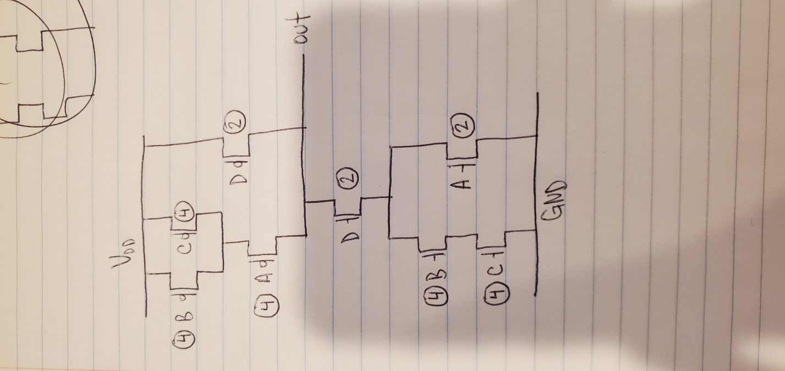

C: **Worst Pull-Up Input: [ABCD] 0101**

**Worst Pull-Down Input: [ABCD] 0111**

D: **Worst tpHL would be moving between the states from Part C -> 0101 to 0111**